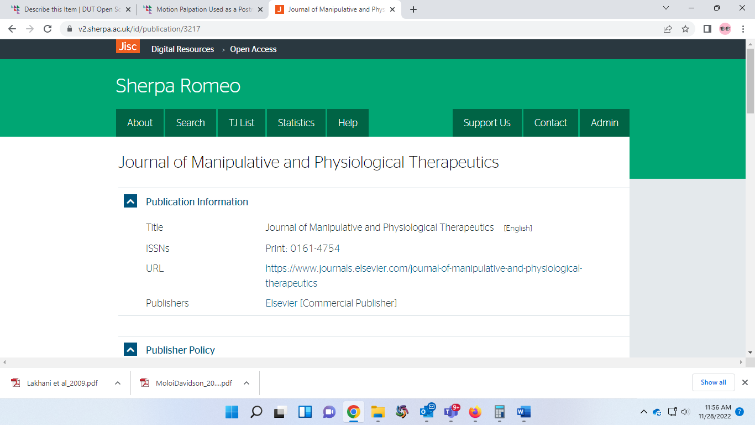

Journal of Manipulative and Physiological Therapeutics Therapeutics